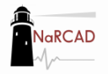
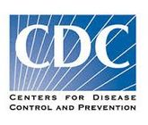
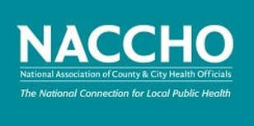
Individual Visits: Detailing Session Notes Form
Other Topics:
6. Naloxone
7. Harm Reduction
8. Titration
9. Inherited Patients
10.Other (describe in notes)
Key Messages List:
1. Start Low and Go Slow (includes calculating doses)
2. Use Non-Opioid Treatment
3. Review the PDMP
4. Avoid Concurrent Prescribing
5. Offer Treatment or Referral for OUD (Opioid Use Disorder)

 |  | Notes:
Clinician Name: | Ann Jones, RN | Also knows Suzanne Montgomery from SafeNet, will follow up with introductory e-mail
Clinic: | East Safety Net Clinic, Downtown | Part of Safety Net Health System
Visit Occurred: | 10/30/2018 | Rescheduled twice; realize that Practice Manager Greg Smith is best point of contact, not reception
Length of Visit: | 20 minutes | Originally scheduled for half hour, Ann was running behind
General Reception: | Positive/receptive | Was trained in 90’s, taught that long-acting opiates had no risk of being addictive; wants to find ways to help her patient population especially veterans who she’s received as legacy patients. Challenging to engage at first; asked more needs assessment questions to ask about specific patients who were a challenge to treat.
Key Messages Covered: | 1, 3, 4 | Really wants to start using PDMP more effectively; challenges with introducing into clinic workflow; understaffed team. Suggested assigning delegate via medical assistant, Lars. She will follow up with Lars.
Other topics covered | 6, 8, 9, 10 (veteran population) | Has concerns about whether PDMP really has most up-to-date data, but realizes better to check, especially for vets on Benzodiazepines for anxiety/PTSD
Commitment and Time Period | Will start on November 1st having Lars pull PDMP info each morning for two weeks and see how it goes. | Seems receptive to follow-up and said she’ll keep notes on progress
Follow-up visit plans | Will reach out to Greg in two weeks to set something up for end of November; will also e-mail Lars to check in. | N/A
Resources Offered | 4-pager Detailing Aid on CDC Primary Care prescribing guidelines; pocket card | Really liked pocketcard and asked for a few others when I next visit
Resources to send | PDMP “how to” state tutorial link and CDC 2016 Guidelines | Will send both via e-mail by EOD
Other Notes | Said she would introduce me to other nurses during a staff meeting on 12/2/2018 | Will prepare small presentation for other nurses and plan to speak with Greg about 1:1 visits with each nurse thereafter

