2016 Conference Speaker Directory

Michael Ascari, PharmD, MS
Chief of Pharmacy | Department of Veterans Affairs
Long Beach, CA | michael.ascari@va.gov
Sarah Ball, PharmD
Research Assistant Professor | Division of General Internal Medicine and Geriatrics Medical University of South Carolina
Charleston, SC | ballsj@musc.edu

Mark Bounthavong, PharmD, MPH
Pharmacy Data Program Manager
VACO Pharmacy Benefits Management | Seattle, WA mark.bounthavong@va.gov

Danelle Callan, MA
Project Manager
University of New Mexico Family & Community Medicine
Albuquerque, NM | dcallan@salud.unm.edu
Melissa Christopher, PharmD
National Director, Academic Detailing Program
Veterans Health Administration
San Diego, CA | Melissa.Christopher@va.gov

Mindy Craig, M.S., PA-C
Director of Physician Outreach
Assuring Better Child Health & Development (ABCD)
Denver, CO | mindy@coloradoabcd.org

Alisha Herrick, MPH
Program Specialist & Academic Detailer
Southwest Center for Health Innovation | Silver City, NM aherrick@swchi.org

Brent Jensen, BSP
Drug Information Specialist | RxFiles Academic Detailing
Saskatoon, SK Canada | jensenb@rxfiles.ca

Amanda Kennedy, PharmD
Associate Professor of Medicine, General Internal Medicine
University of Vermont | Burlington, VT amanda.kennedy@uvmhealth.org

Lynette Kosar, BSP, MSc
Information Support Pharmacist | RxFiles Academic Detailing
Saskatoon, SK Canada | lynette@rxfiles.ca

Ann Kurth, PHD, CNM, MPH, FAAN
Dean | Yale School of Nursing | Orange, CT | ann.kurth@yale.edu

Harald Langaas, MPharm, MPH
Managing Director
Regional Medicines Information & Pharmacovigilance Centre (RELIS)
Trondheim, Norway | harald.langaas@legemidler.no

Karen Lasser, MD, MPH
Associate Professor of Medicine and Public Health
Boston University
Clinician-Investigator | Boston Medical Center
Boston, MA | karen.lasser@bmc.org

Gail Levine, MD
Medical Director | Brigham & Women’s Hospital
Massachusetts Mental Health Center
Boston, MA | glevine@partners.org

Terryn Naumann, BSc(Pharm), PharmD
Director of Evaluation | Medical Beneficiary & Pharmaceutical Services Division, BC Ministry of Health
New Westminster, BC Canada | Terryn.Naumann@gov.bc.ca

Cait O’Sullivan, PharmD
Academic Detailing Pharmacist
BC Provincial Academic Detailing Service
Vancouver, BC Canada | cait.osullivan@viha.ca

Priyanka Randeria, MPH, MHA
Health Systems Specialist, Management Analyst
Veterans Health Administration
Los Angeles, CA | priyanka.randeria@va.gov

Loren Regier, BSP, BA
Co-Director | Centre for Effective Practice
Academic Detailing Service | Toronto, ON Canada Loren.Regier@effectivepractice.org

Robert Rhyne, MD
Project Investigator | University of New Mexico
Albuquerque, NM | RRhyne@salud.unm.edu

James Rick, MD
Primary Care Physician | Long Beach Veterans Administration
Long Beach, CA | James.rick@va.gov

Jess Rogers, BA
Co-Director | Center for Effective Practice
Toronto, ON Canada | jess.rogers@effectivepractice.org

Brenda Schuster, BSP, PharmD
Academic Detailer & Clinical Pharmacist | Regina Qu'Appelle Health Region and RxFiles Academic Detailing Program
Saskatoon, SK Canada | bschuster@sasktel.net

Jacquelyn Travers, PharmD
Academic Detailing Pharmacist
Pharmacy Management Consultants
Oklahoma City, OK | jacki-travers@ouhsc.edu

Mark Viron, MD
Psychiatrist | Massachusetts Mental Health Center
Boston, MA | Mark.Viron@State.MA.US

Steven Weinberger, MD
Associate Executive Vice President | American College of Physicians | Philadelphia, PA | sweinberger@acponline.org

Shirley Yeung, BSc (Pharm), MSc
Academic Detailing Pharmacist | BC Provincial Academic Detailing Service | Vancouver, BC | shirley.yeung@vch.ca

Kathryn Zioto, MD, MPH
Outpatient Psychiatrist | Codman Square Health Center
Dorchester, MA | kazioto@gmail.com
2016 Conference Participant Directory
Victoria Alexander-Carney, MSEd
Director, Learning Design | Signature Healthcare, LLC
Louisville, KY | valexandercarney@shccs.com
Sameer Awsare, MD
Associate Executive Director, The Permanente Medical Group Campbell, CA | sameer.awsare@kp.org
Julia Bareham, BSP, MSc
Manager, Prescription Review Program
College of Physicians and Surgeons of Saskatchewan
Saskatoon, SK Canada | juliabareham@hotmail.com

Cheryl Bartlett, RN, BA
Chief Executive Officer | Alosa Health
Boston, MA | cbartlett@alosahealth.org

Mark Bauer, MD
Visiting Professor
Brandeis University Heller School & Schneider Institutes Waltham, MA | markrbauer@gmail.com

Lisa Bullard-Cawthorne, MS, MPH
Opioid Harm Prevention Program Coordinator
Wisconsin Division of Public Health
University of Wisconsin Population Health | Madison, WI lisa.bullardcawthorne@wi.gov

Nam-Kyong Choi, PhD
Professor, Researcher | Brigham & Women’s Hospital
Boston, MA | namkyong.choi@gmail.com

Aleta Christensen, MPH
Behavioral Scientist | Center for Disease Control and Prevention Atlanta, GA | yno7@cdc.gov

Ellen Dancel, PharmD
Director of Clinical Materials Development | Alosa Health
Boston, MA | edancel@alosahealth.org

Jan DeLaMare, MPA
Researcher | Agency for Healthcare Research and Quality
Rockville, MD | jan.delamare@ahrq.hhs.gov

Roar Dykorn, MD
Senior Consultant | Department for Clinical Pharmacology
St. Olavs Hospital | Trondheim, Norway roar.dyrkorn@legemidler.no

Rebecca Edelberg, MPH
Program Coordinator | Alosa Health
Boston, MA | redelberg@alosahealth.org

Paul Fanikos, RPh, MPA/HA
Clinical Education Director
Alosa Health | Boston, MA | pfanikos@alosahealth.org

Allen Flaming, MSW
Program Manager
Centre for Effective Practice
Toronto, ON Canada | allenflaming@gmail.com

Elisabeth Fowlie Mock, MD, MPH
Academic Detailer
Maine Independent Clinical Information Service (MICIS) Manchester, ME | mockdoc1@gmail.com

Carol Freedman, RPh, MAS, CGP
Pharmacy Services Manager
Northeast Physician Hospital Organization
Beverly, MA | cfreed@nhs-healthlink.org

Amber Gensheimer, MSN, Nursing Education
Director of Clinical Education and Program Development Signature Healthcare, LLC | Louisville, KY agensheimer@signaturehealthcarellc.com

Michael Harvey, PharmD
Program Manager & Data Leader | Veteran's Affairs HCS
Saint Paul, MA | michael.harvey@va.gov

Laura Heesacker, LCSW
Behavioral Health Innovation Specialist
Jackson Care Connect
Medford, OR | Laura.heesacker@gmail.com

Julianne Himstreet, PharmD
National Program Manager for Education and Training
Veterans Affairs | Salem, OR | Julianne.Himstreet2@va.gov

Melissa Hoover
Senior Project Specialist, Pharmacy
Massachusetts General Physicians Organization
Massachusetts General Hospital
Boston, MA | mhoover@partners.org

Margaret Jin, BScPhM, PharmD, MSc
Academic Detailing Coordinator, Academic Detailer, Clinical Pharmacist | Hamilton Family Health Team
Hamilton, ON Canada | margaret.jin@hamiltonfht.ca

Bronwen Jones, MD, CCFP
Program Director, Academic Detailing Service
Dalhousie University | Halifax, NS Canada | bjones3@dal.ca

Hasmeena Kathuria, MD
Pulmonologist and Researcher | Boston University
Boston, MA | hasmeena@bu.edu

Chad Kay, PharmD
Academic Detailing Service Program Manager
Department of Veterans Affairs | Saint Louis, MO Chad.Kay@va.gov

Tamar Klaiman, PhD, MPH
Director, Research and Evaluation | AccessMatters
Philadelphia, PA | tamar.klaiman@accessmatters.org

John Kolsbun, MD
Steering Committee OPG | Oregon Pain Guidance (OPG)
Medford, OR | jkolsbun94@yahoo.com

Douglas Krakower, MD
Physician and Researcher | Beth Israel Deaconess Medical Center, Fenway Health, Harvard Medical School
Boston, MA | dkrakowe@bidmc.harvard.edu

Marcos Lau, PharmD
Academic Detailing Program Manager
Department of Veterans Affairs | Los Angeles, CA marcos.lau@va.gov

Joy Leotsakos, PharmD
Academic Detailing Program Manager | Atrius Health
Boston, MA | Joy_leotsakos@atriushealth.org

Andrew Levitsky, PharmD
Manager of Population Health Pharmacy Services
Lahey Health
Boston, MA | andrew.m.levitsky@lahey.org

Jane Liebschutz, MD, MPH
Assistant Professor of Medicine, Attending Physician
Boston University School of Medicine
Boston Medical Center | Boston, MA | jane.liebschutz@bmc.org

Muffadal Mahesri, MD, MPH
Research Specialist | Division of Pharmacoepidemiology
Brigham & Women’s Hospital
Boston, MA | mmahesri@partners.org

Deborah Monaghan, MD
Public Health Director
Colorado Department of Public Health and Environment
Denver, CO | deborah.monaghan@state.co.us

Janice Murphy, MD
Senior Director - Strategic Alliances & Program Development Alosa Health | Boston, MA | jmurphy@alosahealth.org

Nadejda Razi-Roberston, LCSW, PhD
Behavioral Health Consultant | Plum Consulting, LLC
Ashland, OR | nejisnej@yahoo.com

Sally Reyering, MD
Co-Principal Investigator | Bay Cove Human Services, Inc
Boston, MA | sreyering@baycove.org

Veronica Rosa-DaFonseca, BA
Community Health Network Coordinator
Rhode Island Department of Health
Providence, RI | v.rosadafonseca@health.ri.gov

Kathryn Rough, ScM
Doctoral Candidate | Harvard T.H. Chan School of Public Health Boston, MA | ker704@mail.harvard.edu

Nicole Runner, Health Promotion
Health Program Manager
Idaho Department of Health and Welfare
Idaho Falls, ID | runnern@dhw.idaho.gov

Wayne Saltsman, MD, PhD
Chief Medical Officer, Continuing Care | Lahey Health
Burlington, MA | wsaltsmanmd@gmail.com

Pamela Sherry, PharmD
Director of Pharmacy | Lahey Clinical Performance Network Lahey Health | Beverly, MA | Pamela.S.Sherry@Lahey.org

Jason Smith, PharmD
Director of Academic Detailing Program | Veterans Health Administration | Denver, CO | jason.smith2@va.gov

Denise Summers, PharmD
Clinical Readmissions Prevention Pharmacist
Winchester Hospital/CHART
Winchester, MA | summers_denise@hotmail.com

Monica Tavares, BS
PDMP Education and Outreach Coordinator
Rhode Island Department of Health
Providence, RI | Monica.Tavares@health.ri.gov

Skye Tikkanen, MS, CSAC, LPC, CS-IT
Project Manager, Drug Poisoning Prevention Initiative
Safe Communities Madison-Dane County
Madison, WI | stikkanen@safercommunity.net

Elizabeth Toabe, PharmD
Accountable Care Organization Pharmacist
Winchester Hospital | Lahey Clinical Performance Network
Beverly, MA | etoabe@winhosp.org

Nathaniel Tran, BA
Assistant Program Coordinator
Dana-Farber Cancer Institute
Boston, MA | NathanielM_Tran@dfci.harvard.edu

Renda Wiener, MD, MPH
Physician | Department of Veterans Affairs
Bedford, MA | rwiener@bu.edu

Kim Wong, PharmD
Manager of Pharmacy Operations | Neighborhood Health Plan
Boston, MA | kim_wong@nhp.org

Christine Yu, MD
MBA | Columbia University
New York City, NY | CYu17@gsb.columbia.edu

Kathryn Zioto, MD, MPH
Outpatient Psychiatrist | Codman Square Health Center
Dorchester, MA | kazioto@gmail.com

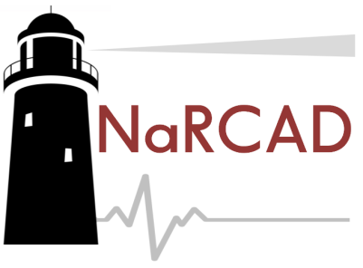

Jerry Avorn, MD, Co-director
javorn@partners.org

Michael Fischer, MD, MS, Director
mfischer@partners.org

Niteesh Choudry, MD, PhD, Faculty
nchoudry@partners.org

Bevin K. Shagoury, Communications & Education Director
bshagoury@partners.org

Arielle Mather, MPH, Education & Training Manager
amather1@partners.org

General Inquiries: narcad@partners.org
narcad.org | 419 Boylston Street, 6th Floor
Conference Map & Breakout Session Room Assignments
Please refer to your program guide for detailed breakout session descriptions

Day 1 Breakout Sessions: “AD in Action”

- AD 101: Deconstructing an AD Visit
Room 216 (2nd floor)

- “It’s All in the Detailer”: A Team-Building Perspective
Room 217 (2nd floor)

- Building Strategic Partnerships: Increasing Access & Impact
Rotunda (3rd floor, where all main sessions are held)

Day 2 Breakout Sessions: “Advanced Lessons in AD”

- Creating Clear Messaging from Complex Clinical Topics
Room 217 (2nd floor)

- Topic Workshop: Opioid Safety
Room 216 (2nd floor)

- Pragmatic Program Evaluation
Rotunda (3rd floor, where all main sessions are held)

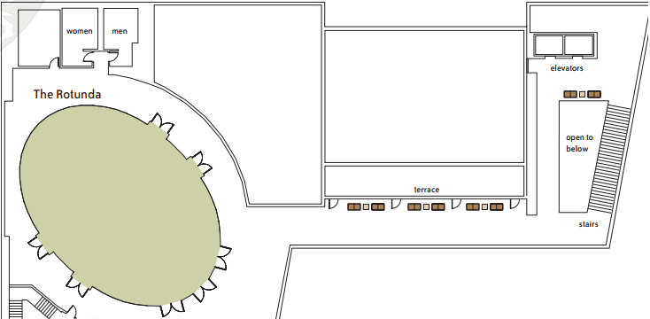

3rd Floor Map:
All Main Sessions

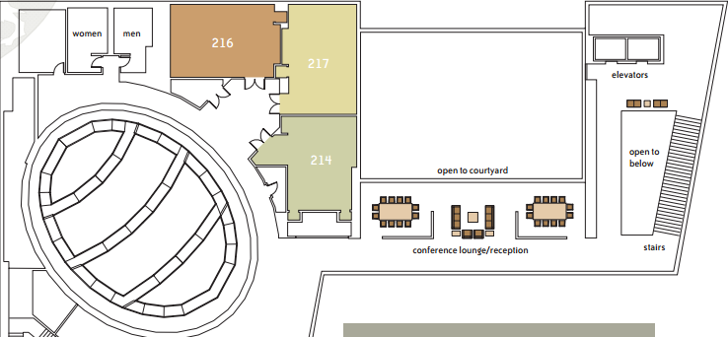

216 217

2nd Floor Map:
Breakout Rooms
216 & 217

